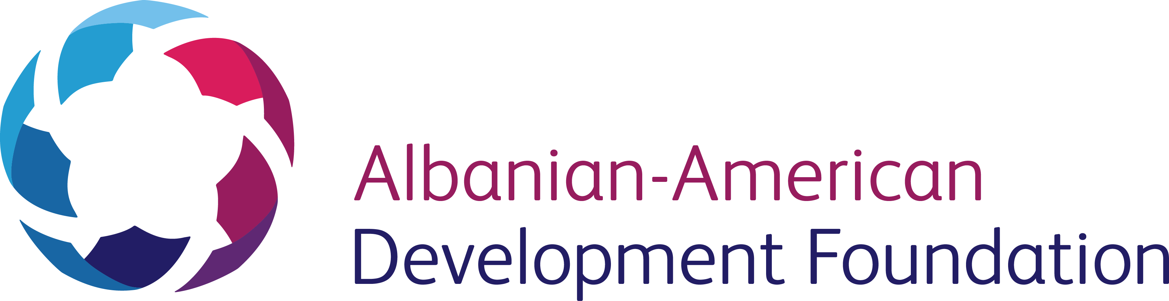

CULTURE CORPS – YOUNG CULTURAL INNOVATORS DRIVING CHANGE
APPLICATION FORM

PLEASE FILL CLEARLY IN ENGLISH
PERSONAL INFORMATION

As written in your passport
FAMILY (LAST) NAME: Click here to enter text.
GIVEN (FIRST) NAME: Click here to enter text.
MIDDLE NAME: Click here to enter text.
BIRTHDATE: DAY/ MONTH / YEAR : Click here to enter text.
CITIZENSHIP : Click here to enter text.
GENDER: Choose an item.
BUSINESS ADDRESS

POSITION: Click here to enter text.
ORGANIZATION: Click here to enter text.
STREET ADDRESS: Click here to enter text.
CITY: Click here to enter text.
COUNTRY: Click here to enter text.
CONTACTS

E-MAIL ADDRESS: Click here to enter text.
MOBILE NUMBER: Click here to enter text.

To complete the application process, please include a curriculum vitae and a personal statement. All documents should be submitted in English.
The deadline for this application is: 25 JUNE 2016
Please send your application to : info@aadf.org
Successful applicants will be contacted for an interview
NOTE: Proficiency in spoken and written English is a prerequisite for this application.

